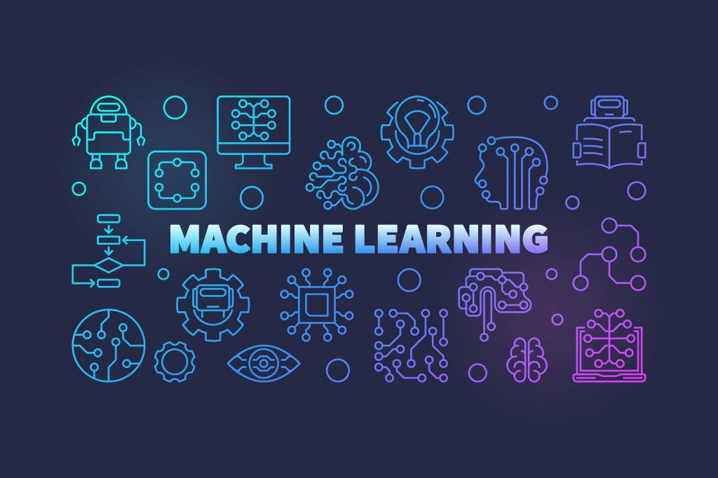

ACM ML SMP

Assignment-1

SUSHSANTH | 9916738256 | 07/04/20 | EEE

# DEEP LEARNING vs MACHINE LEARNING

**Machine learning**is a subset of artificial intelligence associated with creating algorithms that can change themselves without human intervention to get the desired result – by feeding themselves through structured data.

**Deep learning** is a subset of machine learning where algorithms are created and function similarly to machine learning, but there are many levels of these algorithms, each providing a different interpretation of the data it conveys. This network of algorithms is called artificial neural networks. In simple words, it resembles the neural connections that exist in the human brain.

* The main difference between deep learning and machine learning is due to the way data is presented in the system. Machine learning algorithms almost always require structured data, while deep learning networks rely on layers of ANN (artificial neural networks).
* Another difference between deep and machine learning is, machine learning models become better progressively but the model still needs some guidance. If a machine learning model returns an inaccurate prediction then the programmer needs to fix that problem explicitly but in the case of deep learning, the model does it by itself. Automatic car driving system is a good example of deep learning.
* It is worth noting that, given the number of layers, hierarchies, and concepts that these deep learning networks handle, Deep learning is only suitable for performing complex calculations, not simple ones, because minor datasets are not capable of training these networks to produce accurate results that they are supposed to & capable of producing.

In my opinion, ML cannot be wiped out completely by DL, because of it’s intricate algorithm. As mentioned, DL relies heavily on complex datasets to increase it’s efficiency. ML solves minor problems by accepting structured data and betters itself progressively with minor interventions from the programmer. ML is capable of tackling simpler tasks with smaller structured data-sets and whereas DL might go wrong if the data quality does not match with the standard of the algorithm in place. Also, developing a DL algorithm is an achievement in itself due to the intricacies involved in the concept of deep learning networks. ML models are relatively easier to develop and implement. But looking at the flipped side of the coin, ML cannot handle unstructured/complex data, whereas DL is meant to handle this type of data. Each of these technologies have their own pros and cons and in my opinion neither of them can wipe out each other. But DL has a scope for a lot more growth and higher-grade implementation as future seems to be technology dependent with least human interventions.

## SUPERVISED vs unsupervised vs reinforced

### **Supervised**

Supervised learning is an ML technique which involves mapping of input-output data based on input-output pairs, which are present in the dataset used to train the model. It’s an extremely simple technique of ML and is usually used for smaller scale applications.

Applications – Fraud Detection, Bioinformatics, Speech Recognition, Spam Detection, Classifiers, etc.

Pros

* Supervised learning is easy to comprehend.
* You will have an exact idea about the classes in the training data.
* The number of classes that are present in the model are known before giving the data for training.
* It is possible to train the classifier in a way which has a perfect decision boundary to distinguish different classes accurately.
* Supervised learning yields the best results in classification problems.
* Another typical task of supervised machine learning is to predict a target numerical value from some given data and labels.
* It is not necessary to keep the data used for training. Instead, the decision boundary can be kept as a mathematical formula.

Cons

* Supervised learning is limited in a variety of sense so that it can’t handle some of the complex tasks in machine learning.
* It cannot cluster or classify data by discovering its features on its own, unlike unsupervised learning.
* Supervised learning cannot give unknown information from the training data, unlike unsupervised learning.
* In the case of classification, if we give an input that is not from any of the classes in the training data, then the output may be a wrong class label. For example, let’s say you trained an image classifier with cats and dogs data. Then if you give the image of a giraffe, the output may be either cat or dog, which is not correct.
* While training the classifier, there is a need to select a set of good examples, else the accuracy of the models will be low. This process is tedious if the data set is large.
* Training a model requires a good amount of computation time, and may go up high if the dataset is quite large.

**Unsupervised**

Unsupervised learning is a technique of ML in which the algorithm looks for previously unexpected patterns without predefined labels. It looks to draw inferences from datasets consisting of input data & unlabelled responses. This technique involves very less human intervention.

Applications – Recommendations, Profiling, etc.

Pros

* It can detect what human eyes cannot perceive.
* The potential of hidden patterns can be very powerful for the business or even detect extremely amazing facts, fraud detection etc.
* Output can determine the un explored territories and new ventures for businesses. Exploratory analytics can be applied to understand the financial, business and operational drivers behind what happened.
* One of the important uses is that it requires least human intervention after creation of the model and it’s performance can be easily scaled up.

Cons

* Unsupervised learning is harder as compared to supervised learning.
* It can be a costly affair, as scalability, implementation requires expertise.
* Usefulness of the results; are of any value or not is difficult to confirm since no answer labels are available.

**Reinforcement**

Reinforcement learning is a technique in which a model learns by committing and rectifying mistakes. Reinforcement learning finds it’s applications in solving the complex issues which cannot be addressed by the usual techniques. Reinforcement learning is usually used in combination with another technique of AI. A famous combination is Reinforcement + Deep Learning.

Applications – Traffic Light Control, Robotics, Games, etc.

Pros

* Reinforcement learning can be used to solve very complex problems that cannot be solved by conventional techniques.
* This technique is preferred to achieve long-term results which are very difficult to achieve.
* The model is capable of correcting the errors that it encounters during the process of learning.
* Once an error is corrected by the model, the chances of the same error occuring are very less.
* It can create the perfect model to solve a particular problem.
* In the absence of a training dataset, it is bound to learn from its experience.
* Reinforcement learning is intended to achieve the ideal behavior of a model within a specific context, to maximize its performance.
* Reinforcement learning is useful when there is no information about the subject/environment.
* Reinforcement learning algorithms maintain a balance between exploration and exploitation. Exploration is the process of trying different things to see if they are better than what has been tried before. Exploitation is the process of trying the things that have worked best in the past. Other learning algorithms do not perform this balance.

Cons

* Too much reinforcement learning can lead to an overload of states which can diminish the results.
* Reinforcement learning is not the preferred method for solving minor problems.
* Reinforcement learning needs a lot of data and a lot of computation.
* Reinforcement learning assumes the world is Markovian, which it is not. The Markovian model describes a sequence of possible events in which the probability of each event depends only on the state attained in the previous event.
* Reinforcement learning being used for complex issues implies that the equipment associated with the prototype of the model is quite expensive.